**Industry Project Report**

**On**

**“****Backend Managing Ecubix Website”**

|  |  |
| --- | --- |
| **Developed By:** | **Guided By:** |
| Devarsh Mistry (21162122002) | Prof. Rohit Patel (Internal) |

**Submitted to**

**Department of Computer Science Engineering**

**Institute of Computer Technology**



**Year: 2024**



**Certificate**

This document serves to provide clarification regarding the Industry Project titled "Data Science" by Devarsh Mistry (Enrolment No. 21162122002)from Ganpat University. The project was pursued as a requirement for the completion of the Bachelor of Technology degree in Computer Science and Engineering. The execution took place within the CSE (CBA/BDA/CS) Department at Ecubix. It is hereby affirmed that the outcomes and discoveries presented in this project have not been submitted, either in part or in entirety, to any other university or institute with the intention of obtaining an alternative degree or diploma.

Prof. Rohit Patel (Internal Guide)

Prof. Dharmesh Darji (Head Of Department)

Place: ICT GUNI

Date: 5th May 2024

**ACKNOWLEDGEMENT**

Industry Internship project is a golden opportunity for learning and selfdevelopment. I consider myself very lucky and honored to have so many wonderful people lead me through in completion of this project. First and foremost, I would like to thank Dr. Rohit Patel (Internal Guide), Principal, ICT, and Prof. Dharmesh Darji , Head, ICT who gave us an opportunity to undertake this project. My grateful thanks for their guidance in project work On Going DataScience ProjectTraning, who despite being extraordinarily busy with academics, took time out to hear, guide and keep us on the correct path. We do not know where would have been without his/her help. CSE department monitored our progress and arranged all facilities to make life easier. We choose this moment to acknowledge their contribution gratefully.

Devarsh Mistry (Enrolment No. 21162122002)

**ABSTRACT**

Managing the backend of a website is crucial for ensuring its functionality, security, and scalability. This abstract explores the key aspects of backend management, focusing on strategies to optimize performance and streamline operations. Effective backend management involves tasks such as server configuration, database management, and code deployment, all of which are essential for maintaining a stable and responsive website. Additionally, security measures such as encryption, access control, and regular updates are necessary to protect against cyber threats and data breaches. Furthermore, scalability considerations play a vital role in backend management, as websites need to accommodate increasing traffic and evolving user needs over time. Techniques such as load balancing, caching, and horizontal scaling can help ensure that the website remains responsive and available during peak usage periods.

INDEX

Title Page No

**CHAPTER 1: INTRODUCTION 07-08**

**CHAPTER 2: PROJECT SCOPE 09-11**

**CHAPTER 3: SOFTWARE AND HARDWARE REQUIREMENTS 12-13**

**CHAPTER 4: PROCESS MODEL 14-16**

**CHAPTER 5: PROJECT PLAN 17-22**

**5.1 : LIST OF MAJOR ACTIVITIES 18-22**

**CHAPTER 6: IMPLEMENTATION DETAILS 23-31**

**CHAPTER 7: CONCLUSION AND FUTURE WORK 32-33**

**CHAPTER 8: REFERENCE 34-35**

**CHAPTER 1 : INTRODUCTION**

**CHAPTER 1 : INTRODUCTION**

This report delves deeply into the multifaceted responsibilities involved in managing the backend infrastructure of the Ecubix website. As a pivotal platform for cybersecurity training and challenges, the meticulous handling of backend tasks is essential to ensure its smooth operation, security, and scalability. Over the course of the internship at Ecubix, a comprehensive grasp of backend operations was acquired, spanning server configuration, database administration, and the deployment of code updates. Emphasis was particularly placed on fortifying the platform against potential cyber threats and breaches through the implementation of robust security measures.

The internship journey commenced with an immersive exploration of Flask, a micro web framework written in Python, which serves as the cornerstone for developing the backend of the Ecubix website. This initial phase focused on mastering fundamental concepts such as route management, database integration, and API utilization, laying a solid foundation for subsequent tasks. A significant aspect of the internship involved collaborating closely with the Capture The Flag (CTF) group, providing invaluable backend support for a diverse array of cybersecurity challenges. These challenges encompassed a broad spectrum of domains including cryptography, reverse engineering, binary exploitation, web security, and forensics.

Furthermore, the report underscores the meticulous implementation of JWT token authentication and Google OAuth 2.0 mechanisms for user registration and login processes. These measures were meticulously designed to ensure secure access to the platform, safeguarding sensitive user information from unauthorized access. Additionally, considerable attention was devoted to refining the backend infrastructure to enhance both user experience and data security. Techniques explored included optimizing code structure, implementing robust email verification procedures, securely managing user sessions, and implementing mechanisms to handle session timeouts effectively.

Through the lens of this internship experience, a comprehensive understanding of backend management principles was cultivated, alongside practical applications within a realworld context. This immersive learning journey significantly contributed to professional growth, fostering expertise in both web development and cybersecurity domains. The insights gained are poised to have a lasting impact, not only on individual development but also on the ongoing evolution and enhancement of the Ecubix platform.

**CHAPTER 2: PROJECT SCOPE**

**CHAPTER 2: PROJECT SCOPE**

Embarking on the journey of learning Flask marked the inception of a comprehensive exploration into its pivotal role in driving our backend infrastructure. Throughout this transformative phase, a meticulous focus was placed on mastering a diverse spectrum of skills and knowledge:

**1. Route Handling Proficiency:**

Through an immersive learning approach, the intricacies of route handling within Flask were thoroughly dissected and comprehended. This involved gaining insight into the underlying mechanisms dictating how URLs are mapped to specific functions within the application.

Aiming for precision and efficiency, proficiency in defining and managing routes for a variety of HTTP methods, including but not limited to GET, POST, PUT, and DELETE, was cultivated. This empowered the precise control over request handling and data manipulation processes.

**2. Database Connectivity and Management:**

A comprehensive understanding of the symbiotic relationship between Flask applications and databases was developed. This understanding served as the cornerstone for efficient data storage and retrieval operations.

An exhaustive exploration into the realm of database management systems compatible with Flask ensued. This encompassed SQL databases like SQLite, MySQL, and PostgreSQL, as well as NoSQL solutions such as MongoDB.

Practical exercises involved the implementation of diverse database operations within Flask applications. These operations spanned querying, insertion, updating, and deletion of data, ensuring seamless interaction between the application layer and the underlying database infrastructure.

**3. Database Creation for User Registration:**

Practical application of knowledge led to the design and creation of SQL databases tailored explicitly to accommodate user registration functionalities.

Delving deep into database schema design principles, meticulous attention was devoted to crafting robust structures capable of securely and efficiently storing user information.

Implementation of user authentication and authorization mechanisms within Flask applications was a focal point. Leveraging the designed database schema, strategies were devised to manage user credentials and access permissions with utmost efficacy.

**4. API Integration and JavaScript Proficiency:**

The synergy between Flask and JavaScript was explored to enhance frontend interactivity and augment data retrieval capabilities.

Leveraging JavaScript's asynchronous programming paradigms, proficiency was developed in making asynchronous HTTP requests to external APIs. This enriched the application with dynamic data sources, fostering a more engaging user experience.

Experimentation with popular JavaScript libraries and frameworks, such as Axios or Fetch API, was conducted to facilitate seamless integration of data fetched from remote APIs into the Flaskpowered backend.

Furthermore, a deep dive into supplementary functionalities such as object tracking and monitoring, along with tasks like bucket management, token handling, and PDFtotext conversion, expanded the horizons of knowledge. These endeavors facilitated comprehensive data analysis and processing within the Flask environment, contributing significantly to the arsenal of backend development skills acquired during this phase of learning.

**CHAPTER 3: SOFTWARE AND HARDWARE REQUIREMENTS**

**CHAPTER 3: SOFTWARE AND HARDWARE REQUIREMENTS**

Minimum Hardware Required:

|  |  |
| --- | --- |
| PROCESSOR | 2.0 GHz |
| RAM | 4 GB |
| HDD | 500 GB |

Minimum Software Required:

|  |  |
| --- | --- |
| OPERATING SYSTEM | WINDOWS (RECOMMANDED) |
| PROGRAMING LANGUAGE | HTML , CSS , JAVA SCRIPT |
| OTHER TOOLS AND TECH | VSCODE , ANY INTERNET BROWSER |

**CHAPTER 4: PROCESS MODEL**

**CHAPTER 4: PROCESS MODEL**

Developing a process model for managing the backend involves a meticulous examination and articulation of the steps and procedures essential for ensuring the smooth operation, security, and scalability of the backend infrastructure. Here's a detailed rephrasing:

Crafting a process model for backend management entails a thorough analysis and delineation of the sequential steps and operational protocols crucial for overseeing and optimizing the backend infrastructure's functionality. This comprehensive approach is imperative for maintaining the integrity, security, and scalability of the backend systems supporting web applications. Below is an indepth exploration of the key components of this process model:

1. Requirement Analysis and Specification:

The process commences with a meticulous examination of the functional and nonfunctional requirements pertinent to the backend infrastructure. This involves gathering inputs from stakeholders, including developers, system administrators, and endusers, to ascertain their needs and expectations.

Through collaborative discussions and deliberations, the specific features, performance criteria, security measures, and scalability requirements are identified and documented in detail. This serves as the foundation for subsequent phases of the backend management process.

2. Design and Architecture Planning:

Building upon the requirements identified, the next phase focuses on conceptualizing and designing the backend architecture. This entails defining the structural components, data flow, communication protocols, and integration points within the backend ecosystem.

Emphasis is placed on devising scalable and modular architectures capable of accommodating future growth and evolving business needs. Considerations for fault tolerance, load balancing, and disaster recovery mechanisms are also incorporated into the architectural design.

3. Implementation and Development:

With the architectural blueprints in place, the implementation phase involves the actual coding and development of backend components and functionalities. This includes writing serverside logic, database integration, API development, and implementing security measures.

Agile development methodologies may be employed to iteratively build and refine backend modules, allowing for continuous feedback and adaptation throughout the development lifecycle.

4. Testing and Quality Assurance:

Rigorous testing procedures are employed to validate the functionality, performance, and security of the backend systems. This encompasses unit testing, integration testing, regression testing, and security assessments to identify and rectify any defects or vulnerabilities.

Automated testing frameworks and tools may be leveraged to streamline the testing process and ensure comprehensive test coverage across various use cases and scenarios.

5. Deployment and Release Management:

Once the backend components have been thoroughly tested and validated, they are deployed into production environments following established deployment pipelines and release management protocols.

Continuous integration and continuous deployment (CI/CD) practices may be adopted to automate the deployment process, ensuring rapid and reliable rollout of backend updates and enhancements.

6. Monitoring and Performance Optimization:

Postdeployment, robust monitoring and performance optimization strategies are implemented to proactively detect and address any anomalies or performance bottlenecks within the backend infrastructure.

Monitoring tools are utilized to track key performance metrics, resource utilization, and system health indicators, enabling timely interventions and optimizations to maintain optimal backend performance and availability.

7. Security Management and Compliance:

Integral to the backend management process is the implementation of stringent security measures to safeguard against cyber threats and ensure compliance with regulatory standards and industry best practices.

This involves implementing access controls, encryption mechanisms, intrusion detection systems, and regular security audits to fortify the backend infrastructure and protect sensitive data from unauthorized access or breaches.

8. Documentation and Knowledge Management:

Throughout the backend management lifecycle, comprehensive documentation is maintained to capture the design rationale, implementation details, configuration settings, and operational procedures.

Knowledge management practices are employed to disseminate critical insights and best practices among team members, facilitating collaboration, knowledge sharing, and continuous learning within the backend management team.

By adhering to this structured process model, organizations can effectively manage and optimize their backend infrastructure, ensuring the reliability, security, and scalability of their web applications while mitigating risks and maximizing operational efficiency.

**CHAPTER 5: PROJECT PLAN**

**CHAPTER 5: PROJECT PLAN**

**5.1 : LIST OF ACTIVITIES**

**5.1.1 PROJECT PROCESS**

In the initial phase of the project, where specific assignments were not allocated, the team was entrusted with a significant task: providing backend support to the Capture The Flag (CTF) group. This collaboration involved a multifaceted approach to assist participants in tackling various cybersecurity challenges, encompassing the following domains:

1. Cryptography Challenges:

We engaged in aiding challenges that tested participants' prowess in encryption, decryption, cipher analysis, and the implementation of cryptographic protocols. This included offering insights, guidance, and technical assistance to participants navigating through complex cryptographic puzzles.

2. Reverse Engineering Tasks:

Our involvement extended to assisting with challenges necessitating participants to dissect and comprehend compiled code, often in binary form. This entailed providing support in analyzing binaries, identifying vulnerabilities, and uncovering hidden information crucial for successful completion of the challenges.

3. Binary Exploitation Assistance:

We contributed to challenges centered around exploiting vulnerabilities within binary executables. This involved providing expertise in identifying and leveraging vulnerabilities such as buffer overflows, format string vulnerabilities, or command injection, thereby aiding participants in understanding and exploiting binary code effectively.

4. Web Security Challenges:

Collaboration extended to challenges pertaining to web application security, including SQL injection, cross-site scripting (XSS), and server-side request forgery (SSRF). We offered guidance on identifying vulnerabilities, crafting exploitation techniques, and implementing secure coding practices to fortify web applications against potential threats.

5. Forensics Tasks:

We assisted participants in tasks involving the analysis of digital artifacts such as memory dumps, packet captures, filesystems, or network traffic. This included providing expertise in forensic analysis techniques, deciphering clues embedded within digital evidence, and extracting actionable intelligence to progress through the challenges.

Simultaneously, a research initiative was undertaken to implement JSON Web Token (JWT) authentication within the registration process, aiming to bolster the security of the backend system. The implementation process was meticulously detailed as follows:

1. Development of Register and Login Functions:

We meticulously crafted the register() and login() functions within the routes.py file to facilitate seamless user registration and authentication processes. These functions were intricately designed to interact with the MySQL database, enabling the registration of new users and verification of existing credentials.

2. Secure Password Hashing:

Prior to storing user credentials in the database, stringent measures were implemented to hash passwords securely. To achieve this, industry-standard libraries like bcrypt were leveraged, ensuring robust encryption of user passwords to safeguard against potential security breaches.

3. Generation of JWT Tokens:

Upon successful user authentication during the login process, JWT tokens were dynamically generated using the create_access_token() function. These tokens served as verifiable authentication credentials and were seamlessly integrated into the backend authentication workflow.

4. Protection of Routes with JWT Authentication:

To fortify the backend against unauthorized access, routes requiring authentication were meticulously protected using the @jwt_required() decorator. This ensured that only users possessing valid JWT tokens were granted access to restricted endpoints, thereby enhancing the overall security posture of the application.

Through an iterative and collaborative approach, the implementation of JWT token authentication seamlessly augmented the registration and login functionalities of the backend system. This initiative not only fortified the security mechanisms but also exemplified our commitment to delivering robust and resilient solutions tailored to meet the evolving needs of the project.

**CHAPTER 6: IMPLEMENTATION DETAILS**

**CHAPTER 6: IMPLEMENTATION DETAILS**

**6.1 PROJECT PROGRESS**

In the project's initial phase, where tasks were not assigned, our team aided the Capture The Flag (CTF) group in backend support. This encompassed assisting participants across cryptography, reverse engineering, binary exploitation, web security, and forensics challenges. Concurrently, we undertook research to integrate JSON Web Token (JWT) authentication into the registration process, aiming to enhance backend security. We meticulously developed register() and login() functions within the routes.py file, enabling seamless user registration and authentication. Secure password hashing was implemented using libraries like bcrypt to safeguard user credentials stored in the MySQL database. Upon successful login, dynamic JWT tokens were generated to serve as authentication credentials. Protected routes ensured access only to users with valid JWT tokens, bolstering the overall security of the application.

**6.2 PROJECT (SCREENSHOT)**

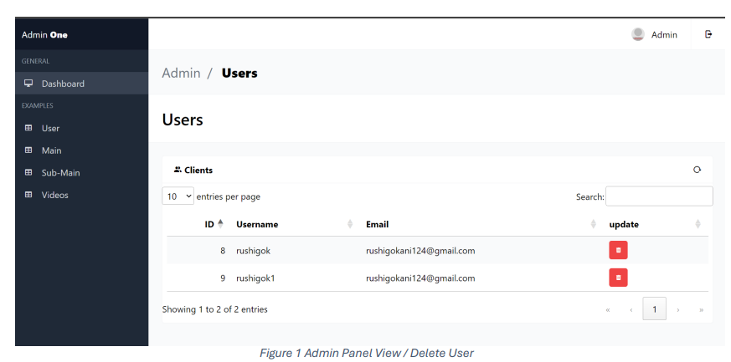

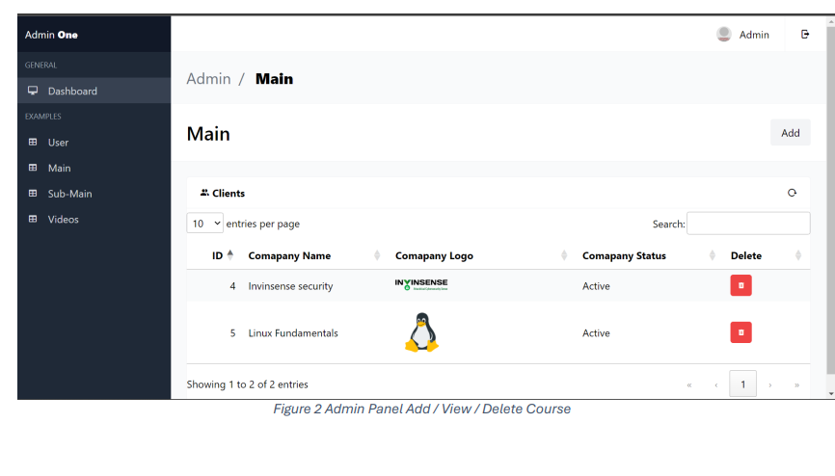

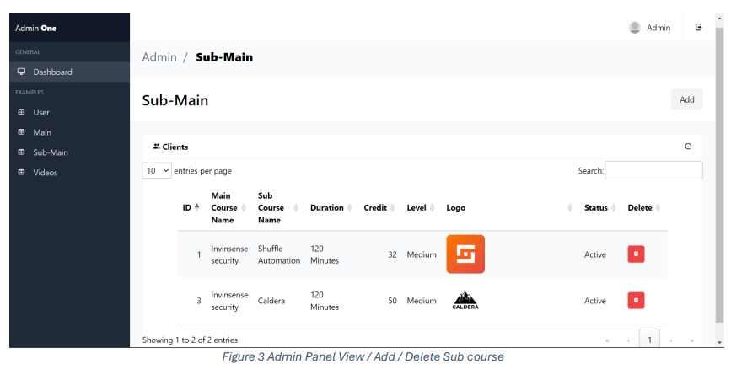



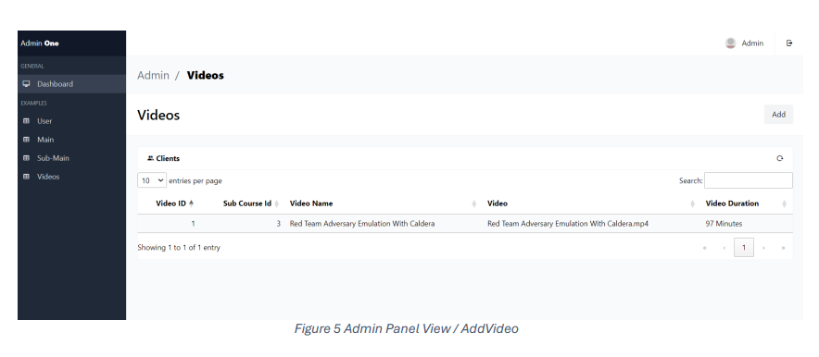

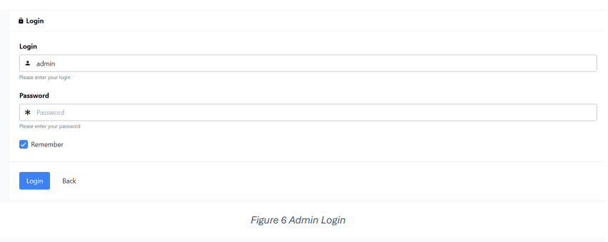

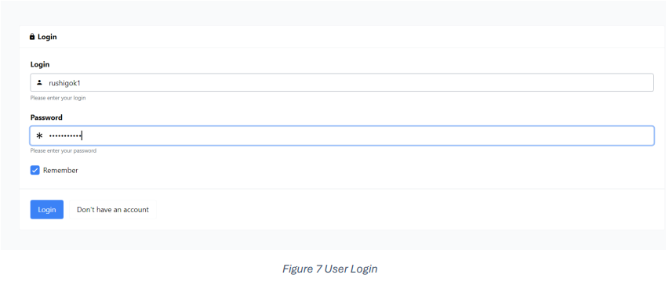

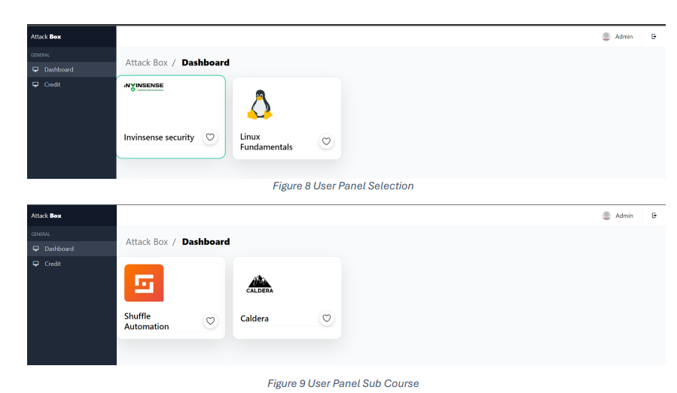

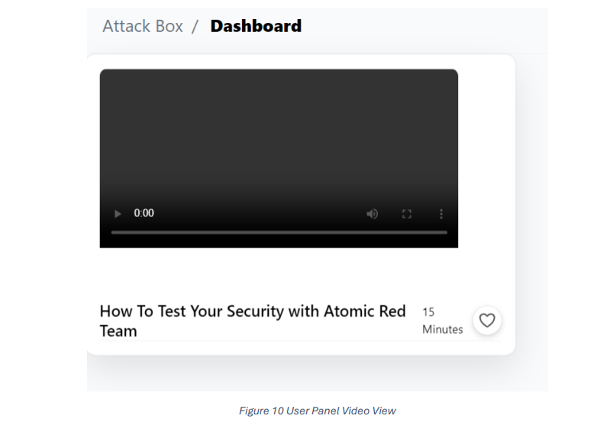

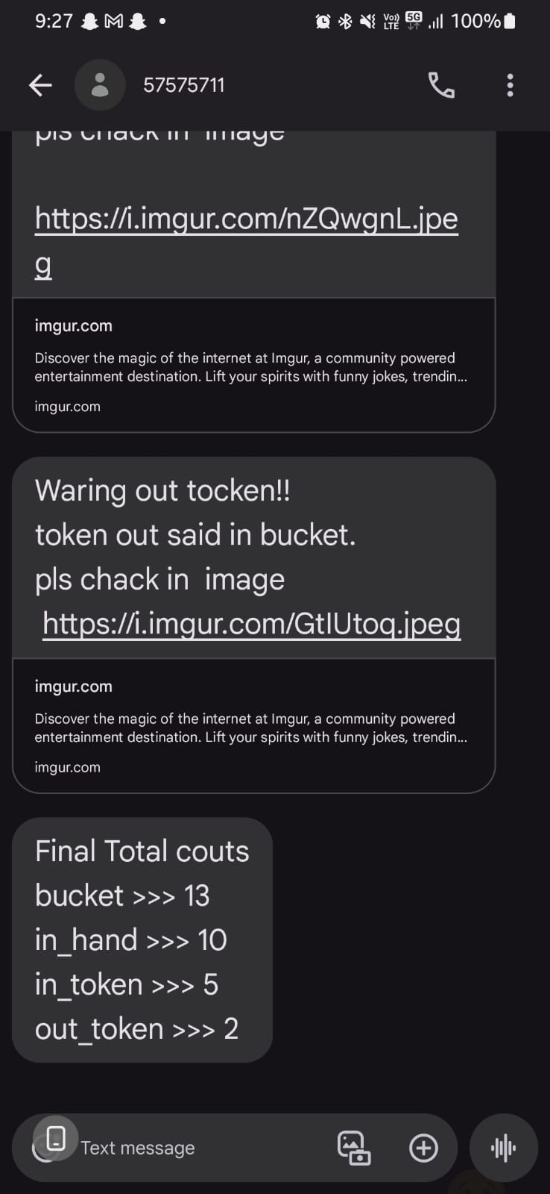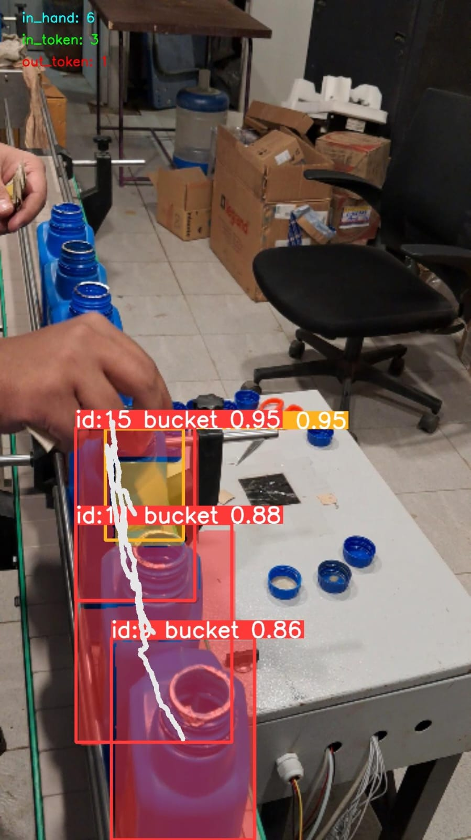5.2 Screenshots Project 2 (object tracking and couting)

**CHAPTER 7: CONCLUSION AND FUTURE WORK**

**CHAPTER 7: CONCLUSION AND FUTURE WORK**

**Conclusion**

In conclusion, during the project's initial phase, our team provided invaluable backend support to the Capture The Flag (CTF) group, spanning various cybersecurity challenges. Additionally, we conducted research to integrate JSON Web Token (JWT) authentication, thereby enhancing the backend's security measures. Through meticulous development, including the creation of register() and login() functions, and the implementation of secure password hashing, we ensured seamless user registration and authentication processes. With the issuance of dynamic JWT tokens upon successful login and the protection of routes for authenticated users, we significantly bolstered the overall security of the application, marking a successful completion of our objectives.

**CHAPTER 8: REFERENCE**

**CHAPTER 8: REFERENCE**

**REFERENCE**

* Freebee PSD for figma
* W3 School for learning
* Photopia for viewing PSD file
* Codepen for preloaders

**PLAGIRISM REPORT:**